**Web Programming**

**(LAB Session-11)**

**Working with PHP Session**

1. **You need to write a php program that create and use session for your website.**
2. **Create a website with two web pages (page1 and page2). There should be a navigation link for the user on page-1 to go to page-2(a button like click here to go to next page)**
3. **When user is on page-1, start a session using session_start() and store below information as session variablei.username= (your name)ii.product= laptopiii.session_start = current timeiv.session_end= current time + 1minutev.Print a message using alert box saying saying session is started.**
4. **After this, click on the next page button and go to page-2.**
5. **On page-2, print the value of the username, product and session_start session variable.**
6. **On page-2, whenthe current time equals or passes the $_SESSION[“session_end”] time, you need to show user a popup alert saying your session has expired now. (Hinet: one of the basic way to do this is to refresh your page after every specified amount of time and check ifthe session is expired or not. This linewith meta tag in header section will refresh your page after every 10 second and will keep you on the same page: <meta http-equiv="refresh" content="10" URL="$_SERVER['PHP_SELF']">)**

**1 -> Third.php**

**Code:**

<!DOCTYPE html>

<?php

session_start();

?>

<html lang="en">

<head>

<meta charset="UTF-8">

<meta http-equiv="X-UA-Compatible" content="IE=edge">

<title>PHP Cookies</title>

</head>

<body style="text-align: center;background-color:black;color: white">

<form action="fourth.php">

<?php

$_SESSION['username']='Arjun Vankani';

$_SESSION['subject']='Maths';

$_SESSION['start_time']=time();

echo "<h3>Username:-".$_SESSION['username']."</h3>";

echo "<h3>Subject:-".$_SESSION['subject']."</h3>";

echo "<h3>Start-time:-".$_SESSION['start_time']."</h3>";?>

<input type="submit" name="submit" value="Submit">

</form>

</body>

</html>

**2 -> Fourth.php**

**Code:**

<!DOCTYPE html>

<?php

session_start();

$en1=$_SESSION['start_time']+60;

?>

<html lang="en">

<head>

<meta charset="UTF-8">

<meta http-equiv="X-UA-Compatible" content="IE=edge">

<meta name="viewport" content="width=device-width, initial-scale=1.0">

<meta http-equiv='refresh' content='10' URL="$_SESSION['PHP_SELF']">

<title>Document</title>

</head>

<body style="text-align: center;background-color:black;color: white">

<?php

echo "<h3>Username:-".$_SESSION['username']."</h3>";

echo "<h3>Subject:-".$_SESSION['subject']."</h3>";

echo "<h3>Start-time:-".$_SESSION['start_time']."</h3>";

?>

<?php

if(time()>=$en1){

session_unset();

echo "<script>alert('Session is unset')</script>";

session_destroy();

echo "<script>alert('Session is destroy')</script>";

}

else{

echo "<script>alert('Session is set')</script>";

}

?>

</body>

</html>

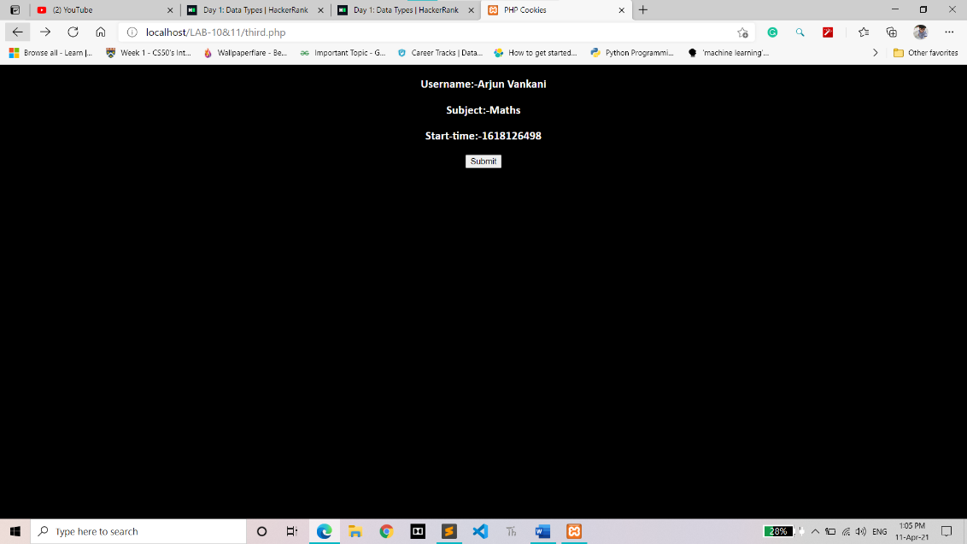**Output:**

